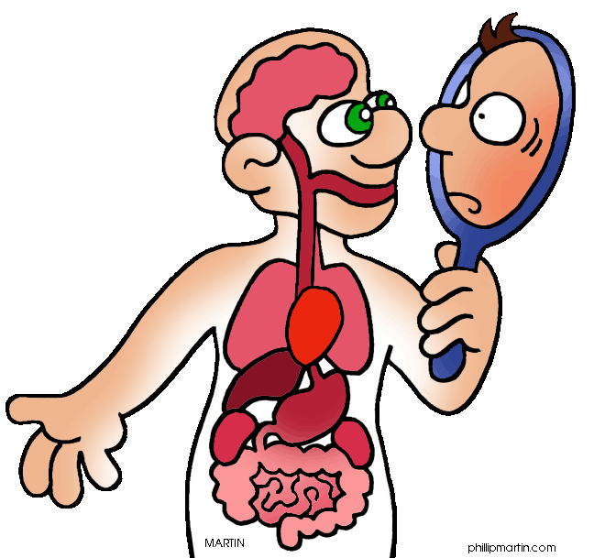
Biology 20 Course Outline
Mrs. Jorgensen - Room 120
Semester 1 – 2018/2019
Join Remind by texting @9df2c4 to (587)800-0547
Jordana.jorgensen@wrps11.ca
Course Content

Unit A: Energy and Matter Exchange in the Biosphere
Chapters 1 and 2 (13 days) Exam: Sept 20th, 2018
Questions we will explore: How are carbon, oxygen, nitrogen and phosphorus cycled in the biosphere? How is the flow of energy balanced in the biosphere? How have human activities and technological advances affected the balance of energy and matter in the biosphere?
Key Concepts:
-biosphere -food chains, food webs and ecological pyramids
-equilibrium - carbon, nitrogen, oxygen and phosphorus cycles
-trophic levels - water properties

Unit B: Ecosystems and Population Change
Chapters 3 & 4 (22 days, includes field study) Exam: Oct25th, 2018

Questions we will explore: What are the major biotic and abiotic characteristics that distinguish aquatic and terrestrial ecosystems? What data would one need to collect in a field study to illustrate the major abiotic characteristics and diversity of organisms? What mechanisms are involved in the change of populations overtime? In what ways do humans apply their knowledge of ecosystems to assess and limit the impact of human activities?

Key Concepts:
-ecosystem -adaptation and variation -niche
-biotic/abiotic -population -species
-natural selection -evidence of evolution -limiting factors
-binomial nomenclature

Unit C: Photosynthesis and Cellular Respiration
Chapter 5 (12 days) Exam: Nov 16th, 2018
Questions we will explore: How does light energy from the environment enter living systems? How is the energy from light converted to chemical potential energy in organic matter? How is the energy in organic matter released for use by living systems? How do humans in their application of technologies impact photosynthesis and cellular respiration?
Key Concepts:
-absorption of light by pigments - Krebs Cycle
-light independent and light-dependent reactions -electron transport systems
-glycolysis -aerobic and anaerobic respiration

Unit D: Human Systems
Part 1: Chapters 6,7 & 10 (16 days) Exam: Dec 12th, 2018 Part 2: Chapters 8 & 9 (15 days) Exam: Jan 16th , 2019
Questions we will explore: How do specialized structures function in the overall biochemical balance of the living system? What conditions result if these structures do not function normally? How does knowledge of living systems and medical technology support the prevention and treatment of disorders?
Key Concepts:
-structure and function of major -digestive enzymes -gas exchange
systems: respiratory, digestive, -renal function -blood
excretory, circulatory and motor -muscle contraction -immune response
-chemical nature of carbohydrates, -chemical & physical digestion -proteins, lipids

Course Evaluation
Labs: Labs will be performed and students are responsible for completing the appropriate lab work and assignments.
Evaluative Weightings
1. Labs/ Assignments 10%
2. Quizzes 20%
3. Unit Exams 40%
4. Final Exam 30%
Report card marks are cumulative

Assignments: There will be assignments throughout the semester, some will be done as “in class” assignments and others will be “take home”.

Quizzes: There will be weekly “Friday quizzes” (unless there is unit exam scheduled). Quizzes will be composed of a variety of types of questions, including: short answer, definitions, True/False, fill-in-blank and multiple choice.

Note: The majority of assignments, quizzes will be weighted equally. Teacher discretion may determine that some evaluations have heavier weightings.

Exams: There will be 5 exams in the course. Exams may be composed of multiple choice, numerical response and written response. Unit exam weightings are: Unit A: 20%, Unit B 25%, Unit C 15%, Unit D(1): 20%, and Unit D(2): 20%

Final Exam: There will be a cumulative final exam scheduled during exam week. The exam will consist of both multiple choice, numerical response and short answer questions.

Mrs. Jorgensen’s Expectations

- Every student is expected:
  - To attend, what we do everyday matters!!
  - To demonstrate effort during class time (i.e. participate in class activities), success is a measured by effort!!
  - To respect demonstrate respect - towards myself, classmates, equipment and materials
  - To follow all safety rules applicable to the classroom/laboratory

- Catching up on class notes and missed work due to your absence from class is YOUR responsibility.
  - If classwork/homework was assigned during your absence you will have one day to complete the assigned work for a work completion check.
  - If a quiz is missed due to an excused absence, it is expected that the student complete the missed quiz during the next lunch block (Monday). If the absence is not excused the student may receive a mark of zero.

- Assignment completion – it is expected that all students complete all class work.

- Cell Phone Policy: The use of these devices when not part of the lesson can both be disrespectful and prevent active participation. These devices and other electronics are only to be used when directed by myself. If a student is caught with a cell phone, they will receive one warning and then it will be turned into the office and dealt with according to the school policy.

- Cheating of any kind will not be tolerated. During exams and quizzes, talking or sharing of materials is not allowed. If you are caught cheating on an exam, assignment or quiz, a mark of zero will result.

- Please plan around exam dates. All students are expected to be present when an exam is scheduled. If a student is absent the day of an exam the following will occur:
    - If the absence is excused the student can write the exam by following the WCHS Exam Make-Up Policy (office notified of absence the day of the exam)
    - If the absence is not excused by the parent/guardian the student will receive a mark of zero.

Please see the WCHS website for details regarding student expectations.

https://wetaskiwincomp.ca/students/academic-expectations

School Supplies
- Binder, and/or scribbler
- Colored pens
- Highlighters

Textbook Resourse:

http://learningcentre.nelson.com/student/

