
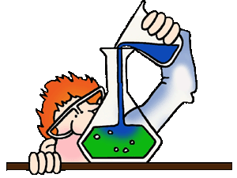
Chemistry 20
Mrs. Jorgensen – Room 101
Semester 1 – 2014/2014
jorgensenj@wrps.ab.ca

Course Content and Timeline:

Unit 1: Chemistry Review
Chapters 1 & 2 Exam date: Wednesday, Sept. 17th
In this unit students will be given the opportunity to review the previously developed Chemistry concepts.
Key Concepts:
- classification of matter - periodic table - atomic theories
- classifying compounds - naming compounds - chemical reactions
- changes in matter - chemical reactions - chemical amounts

Unit 2: The Diversity of Matter and Chemical Bonding
Chapter 3 Exam date: Monday, Oct. 6th
By the end of this unit students will be able to:
- Describe the role of modeling, evidence and theory in explaining and understanding the structure, chemical bonding and properties of ionic and molecular compounds.
Key Concepts:
- chemical bonding - ionic bonding -intra/intermolecular forces
- hydrogen bonding - covalent bond - electron dot diagram
- electronegativity - Lewis structures - polarity
- valence electron - VESPR theory

Unit 3: Forms of Matter: Gases

Chapter 4 Exam date: Thursday, Oct. 23rd
By the end of this unit students will be able to:
- Explain molecular behaviour, using models of the gaseous states of matter.
Key Concepts:
- Celsius and Kelvin temperature scales - Boyle’s and Charles Law - SATP/STP
- real and ideal gases - law of combining volumes - absolute zero

Unit 4: Matter as Solutions (13 days)
Chapter 5 Exam date: Friday, Nov 14th
By the end of this unit students will be able to:
- Investigate solutions, describing their physical and chemical properties.
Key Concepts:
- homogeneous mixtures - solubility - Arrhenius theory
-molar concentration - dilution

Unit 5: Acids and Bases (11 days)
Chapter 6 Exam date: Tuesday, Dec 2nd
Describe acidic and basic solutions qualitatively and quantitatively.
Key Concepts:
- weak acids and bases - indicator - pH and pOH
- monoprotic/polyprotic acids/bases - strong acids and bases

Unit 6: Stoichiometry (11 days)
Chapters 7 Exam date: Thursday, Dec 18th
By the end of this unit students will be able to:
- Explain how balanced equations indicate the quantitative relationships between reactants and products involved in chemical changes.
Key Concepts:
- chemical reaction equations - net ionic equations - spectator ions - precipitation - limiting and excess reagents - reaction stoichiometry

Unit 7: Applications of Stoichiometry (12 days)
Chapters 8 Exam date: Friday, January 16th
By the end of this unit students will be able to:
- Use stoichiometry in quantitative analysis.
Key Concepts:
- equivalence point - titration - end point
- limiting and excess reagents - reaction stoichiometry

Review – January 17th, 18th and 19th

Course Evaluation:

You will be exposed to various forms of activities throughout the course and not all will be given marks. “Assessment” describes all of the activities used to gauge your progress. There are three categories used in this course. Assessment OF learning (Summative Assessment) is done at the end of a learning process; a mark is assigned. Assessment FOR learning (Formative Assessment) occurs during the learning process; you get feedback without a grade. Assessment AS learning is a check of your knowledge at a particular point in time; you determine how well you know a concept (“I don’t know, I need help” or “I know it well, no more practice needed”).
Looking at sport as an analogy, can you imagine what the game would be like if the players didn’t practice? Formative Assessment is the practice – there is no score, teacher coaches you, you ask questions, classmates work with you. Summative Assessment is the game – the game you play that day is the score that goes on record. Practice increases your chance for a better game!

Unit Exams 50 %

Quizzes 10 %
Assignments/Labs 10 %
Final 30 %

Exams ~ The weighting on all the exams will not be equal, as the marks will be calculated using the raw scores on the exam. This will result in longer exams and longer units having a slightly heavier weighting. Exams are cumulative and will consist of multiple choice, numerical response questions and written response. Exams will be 80 minutes in length.

Lab reports ~ There will be periodic labs throughout the semester. Some of the labs will require partial or full write ups to be submitted for marking. Any missed lab that is unverified will result in a grade of zero. The weighting of the above will not be equal, as the marks will be calculated using the raw scores.

Assignments ~ Periodic in-class assignments will be given throughout the semester. Any missed assignment that is unverified will result in a grade of zero. The weighting of the above will not be equal, as the marks will be calculated using the raw scores.

Quizzes ~ Every Tuesday (Testy Tuesday) there will be a cumulative quiz composed of a variety of questions including short answer, multiple choice, and numerical response. Quizzes will not be longer than 40 minutes each. Any missed quiz must be written at lunch on the day you return to class and unverified absences will result in a zero. The weighting of the above will not be equal, as the marks will be calculated using the raw scores.

Final Exam ~ Cumulative exam consisting of multiple choice, numerical response, and a written response components.

Student Expectations:

- Every student is expected:
  - To keep good attendance, what we do everyday matters!!
  - To demonstrate effort during class time (i.e. participate in class activities), success is a measured by effort!!
  - To respect demonstrate respect - towards myself, classmates, equipment and materials,
  - To follow all safety rules applicable to the classroom/laboratory

- Catching up on class notes and missed work due to absence from class is YOUR responsibility.

- Lab reports are an important component of this course. If a lab is missed, YOU are expected to obtain data from your group and have your own lab write-up completed on the due date.

- Assignments are due at the beginning of the class. Late assignments that have been MARKED and returned to the class will not be rewarded marks.

- Cell Phone Policy: These are only to be used when directed by myself. If a student is caught with a cell phone, it will be turned into the office and dealt with according to the school policy.

- Cheating of any kind will not be tolerated. If you are caught cheating on an exam, assignment or quiz, a mark of zero will result. During exams and quizzes, talking or sharing of materials is not allowed.

Students at WCHS are allowed re-writes on unit exams throughout the course they are taking. Re-write permission is given at the discretion of the teacher. The teacher takes the following into account when deciding if a student is allowed a re-write on an exam:

- the student has shown consistent effort in class, completing the classwork for which the evaluation covers
- the student does not have unexcused absences during the classes the evaluation covers
- the student completes any assignments that the teacher has provided in preparation for the re-write

Parental/guardianship signature is required for a student to re-write an exam. Students must re-write the exam on one of the dates provided by the teacher, in room 103 after school.



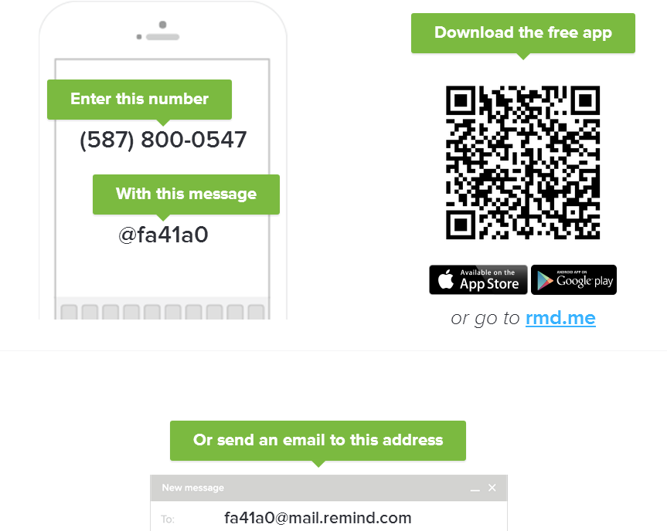
Remind (Formerly Remind101) is a free, safe, and easy way for teachers to connect instantly with students and parents

