Physics 20 Name:
Dynamics and Gravitation
Review Questions

Additional Formulae $F_{g\text{//}}=\text{mg}\text{sin}θ$ $F_{g⊥=\text{mg}\text{cos}θ}$

1. A 20 kg mass is acted on by a 75 N force to the East, and by a 25 N force to the West. The acceleration of the mass will be

A. 2.5 m/s² East B. 2.5 m/s² West
C. 5.0 m/s² East D. 5.0 m/s² West

2. When you are stopped at a red light, your vehicle is rear ended by a truck which failed to stop in time. During the collision, you feel as though you are forced toward the rear of your vehicle. The best explanation of this phenomenon is that

A. since the car is forced forward, you are forced backward (because of Newton's third law)
B. you are forced forward, but since the vehicle is forced forward a greater amount, you feel as though you move backward
C. you remain in the same relative position because of your inertia, but the vehicle is forced forward against your back
D. your car seat exerts a backward force on you

3. A net force of 6.6 N acts on a 9.0 kg mass for a period of 6.0 s. If the object accelerates uniformly from rest, then the distance traveled by the mass while accelerating is

A. 4.1 m B. 4.4 m C. 13 m D. 25 m

4. The force of friction between a 15.0 kg box and the floor is 175 N. The value of the coefficient due to friction is

A. 0.841 B. 0.857 C. 1.17 D. 1.19

5. A student weighs a textbook on Earth and finds the weight to be 15 N. If the student could take the textbook to the moon (g_{moon} = 1.6 m/s²), then the mass and weight, respectively, would be

mass weight
A. 0.25 kg 15 N
B. 15 N 0.25 kg
C. 1.5 kg 2.5 N
D. 9.4 kg 1.5 N

6. Which is the best description of the mass of an object?

A. the number of particles that make up the object
B. the space occupied by the object
C. the amount of matter in the object
D. the force of gravity acting on the object near the surface of the Earth

7. Which of the following will not result in a larger frictional force between a mass and the surface it is on?

A. placing weights on top of the object
B. turning the object onto a larger side, so that there is more surface area between the object and the surface
C. taking the object and the surface to a planet where the acceleration due to gravity is larger in magnitude
D. pushing the object horizontally by applying a downward angled force

1.0 kg
2.5 kg
8. If the coefficient of friction between the 1.0 kg mass and the
table is 0.95, then the acceleration of the system will be

A. 4.3 m/s² B. 5.5 m/s²
C. 6.1 m/s² D. 7.0 m/s²

9. When a student jumps forward off of a skateboard, the
skateboard is forced backward. The reason the board goes
backwards can best be explained by Newton's

A. first law B. second law C. third law D. pet cat Snowball

10. An elevator in a large building is accelerating down with a rate of 2.50 m/s2. If the mass of the elevator (and the people in it) is 2550 kg, then the tension in the cable measured in N, expressed in scientific notation to three digits, is a.bc x 10d N. The values of a, b, c, and d are

Use the following information to answer the next two questions.
A 2.00 kg rocket is launched by a student as part of a science project. The student determines that it reaches a maximum height of 255 m.

11. The weight of the rocket is

A. 2.00 N B. 2.00 kg C. 19.6 N D. 19.6 kg

12. The thrust force required to accelerate the rocket vertically upward at 5.80 m/s2 is

A. 8.00 N B. 11.6 N C. 19.6 N D. 31.2 N
13. A force of 80 N is applied to a box by pulling on a rope at an angle of 40o to the horizontal. The vertical component of the force (to two digits) is ab N, and the horizontal component (to two digits) is cd N. The values of a, b, c and d are

14. A 50.0 kg box is initially at rest on the floor where µ is 1.5. A horizontal force of 600 N is applied to the box. The acceleration will be

A. -2.7 m/s² B. 0 m/s² C. 2.7 m/s² D. 12 m/s²

15. Which graph shows the relationship between the gravitational force of attraction of two masses,
and the distance separating them?

F_{g}
r
F_{g}
r
A. B.
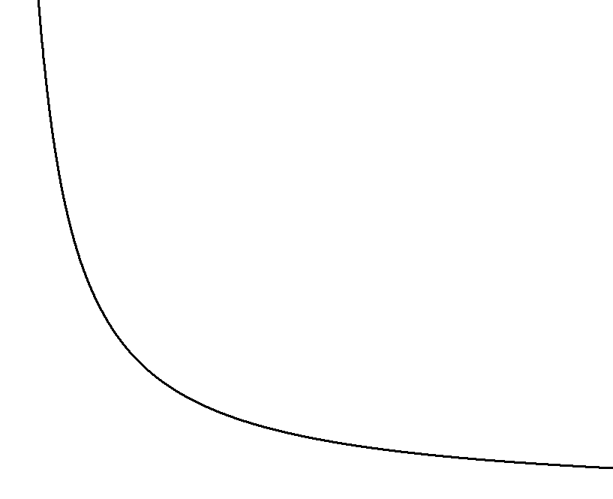
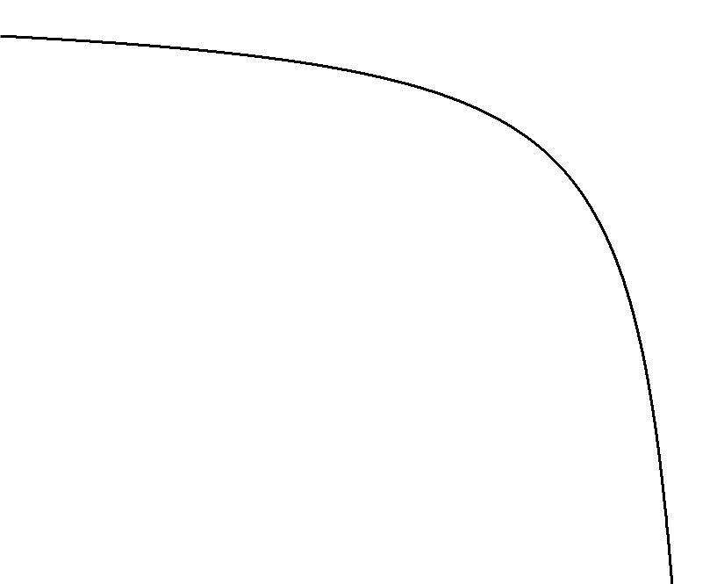

F_{g}
r
F_{g}
r
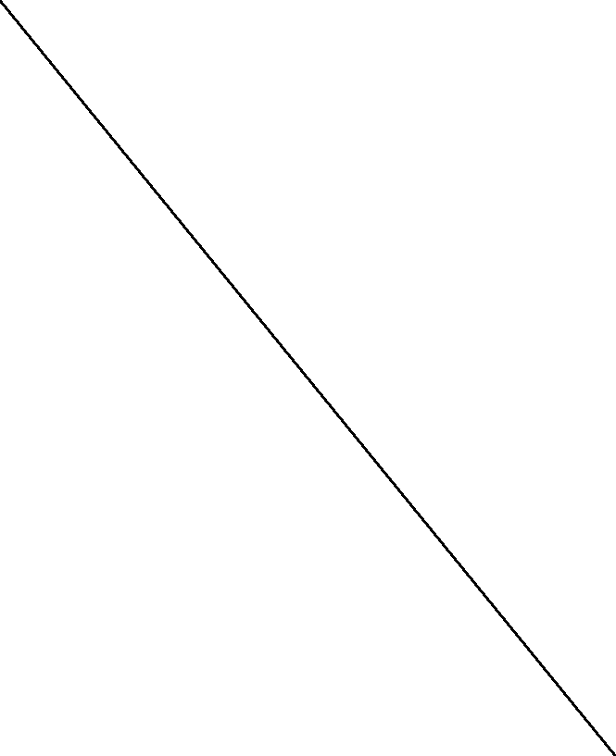
C. D.

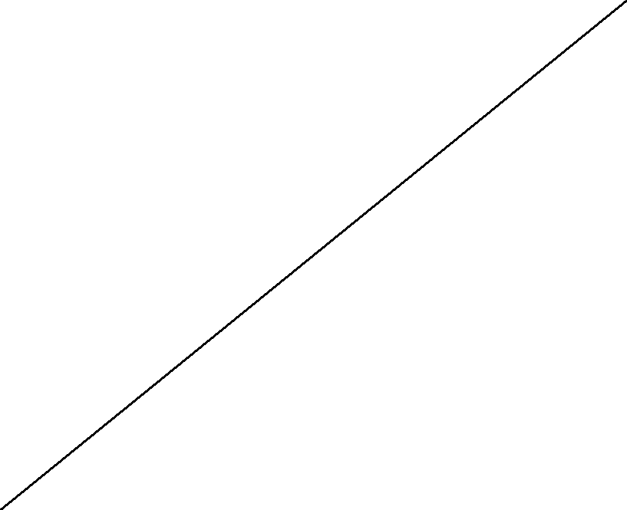

16. Two equal masses are separated by a distance of 2.00 m, and are attracted by a force of 2.50 x 10⁻⁶ N. The mass of each object is

A. 274 kg B. 387 kg C. 37.5 Mg D. 75.0 Mg

17. Two masses separated by a distance experience of gravitational force of 500 N. The mass of one of the objects is tripled and the mass of the other is doubled. If the distance between the two masses is tripled, then the new force of gravitational attraction, measured in N to three digits, is .

18. Two objects in space experience a gravitational attraction. The true statement is that

A. the larger object only pulls on the smaller object.
B. the smaller object only pulls on the larger object.
C. the gravitational fields at the surfaces objects are the same.
D. each object pulls on the other with the same force.

Use the following information to answer the next question.
3.55 cm
3.55 cm
1.19 kg
A
1.19 kg
B
1.19 kg
C

19. The net gravitational force on object B due to the other two objects is:
A. 0 B. $7\text{.}\text{49}×{\text{10}}^{−\text{12}}\text{ N}$ C. $2\text{.}\text{66}×{\text{10}}^{−9}\text{ N}$ D. $7\text{.}\text{49}×{\text{10}}^{−8}\text{ N}$

Use the following information to answer the next two questions.
A 885 kg satellite is in orbit at an altitude of 2.26 x 107 m above the surface of the Earth.

20. The gravitational field strength of the Earth aboard the shuttle, measured in N/kg to three digits,
is .

21. The force of gravity between the satellite and the Earth is a.bc x 10d N. The values of a, b, c, and d respectively are

Use the following information to answer the next two questions:
11 cm
22 cm
45 kg
35 kg
25 kg

22. The magnitude of the net gravitational force experienced by the 25 kg mass, as a result of the 45 kg and 35 kg masses, is

A. 2.6 10⁻¹¹ N B. 5.1 x 10⁻⁶ N C. 2.6 x 10⁻¹⁹ N D. 5.1 x 10⁻¹⁰ N

23. The direction of the net force on the 25 kg mass, measured in degrees to two digits, is º S of W.

Use the following information to answer the next two questions:

22 cm

85 kg
P

11 cm

35 kg

24. The gravitational field at point P is a.b x 10⁻⁷ N/kg, cdº S of W. The values of a, b, c, and d respectively are

25. Two boxes, A and B, of identical material
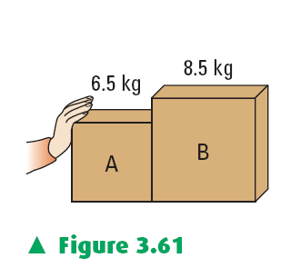
but different mass are placed next to each
other on a horizontal, rough surface, as shown.
An applied force acting on box A causes both
boxes to accelerate at 3.4 m/s² [right]. If the
magnitude of the force of friction between
box B and the floor is 20 N, then the force
exerted by box B on box A, rounded to
two digits is N.

Written Response Questions

1. A 150.0 kg box is placed on an inclined plane where the coefficient of friction is 0.42. The ramp has a height of 12 m and is 24 m long, and is inclined at 30⁰ to the horizontal.

12 m
24 m
30º

a) Calculate the size of the following forces acting on the box:

$F_{g\text{//}}$ = $F_{g⊥}$ = $F_{f}$ =

b) On the diagram above, draw the following forces acting on the box:

$F_{g⊥}$ $F_{g\text{//}}$ $F_{f}$ $F_{N}$

c) Find the net force acting on the box and use it to determine its acceleration.

d) Use your acceleration from part c to find the speed of the box at the bottom of the ramp.

2. Mass and weight are concepts that most people often confuse. As a physics student, you have knowledge of the differences between the two. In the space below, describe four differences between mass and weight.

3. An astronaut lands on a planet and experimentally determines the gravitational field strength to be 7.35 N/kg. Describe
•an experimental method the astronaut could have used
•the data the astronaut would have collected
•how the astronaut would have used the data to find the field strength (be explicit)
4. The following three statements describe what people experience in three different situations:

I. When rear ended by another vehicle, a person in their car feels forced backward.
II. When a bus suddenly stops, the coffee in a person's cup appears to be forced forward.
III. When traveling in a car around a curve on the highway (at a constant speed), people inside the vehicle feel as though they are being forced towards the outside of the curve.

Explain the above observations using inertia and Newton's laws of motion. Include:

•a description of the direction of the real forces on the vehicles (diagrams may be helpful)
•the reasons why we appear to be forced in the directions that we feel we are

Key (MC and NR)

1. A
2. C
3. C
4. D
5. C
6. C
7. B
8. A
9. C
10. 1864
11. C
12. D
13. 5161
14. B
15. A
16. B
17. 333
18. D
19. A
20. 0.48
21. 4202
22. B
23. 72
24. 2359
25. 49
Key (WR)

Note that these solutions are abbreviated.

1. A 150.0 kg box is placed on an inclined plane where the coefficient of friction is
0.42. The ramp has a height of 12 m and is 24 m long, and is inclined at 30⁰ to the horizontal.

$$F_{g\text{//}}$$

a) Calculate the size of the following forces acting on the box:

$F_{g\text{//}}$ = 7.4 x 10² N $F_{g⊥}$ = 1.3 x 10³ N $F_{f}$ = 5.4 x 10² N

b) On the diagram above, draw the following forces acting on the box:

$F_{g⊥}$ $F_{g\text{//}}$ $F_{f}$ $F_{N}$

c) Find the net force acting on the box and use it to determine its acceleration.

F_{net} = 2.0 x 10² N a = 1.3 m/s²

d) Use your acceleration from part c to find the speed of the box at the bottom of the ramp.

8.0 m/s

2. Mass and weight are concepts that most people often confuse. As a physics student, you
have knowledge of the differences between the two. In the space below, describe four
differences between mass and weight.

A complete response must include at least four differences, as well as demonstrate an understanding of the difference between mass and weight.

3. An astronaut lands on a planet and experimentally determines the gravitational field strength to be 7.35 N/kg. Describe
•an experimental method the astronaut could have used
•the data he would have collected
•how he would have used the data to find the field strength (be explicit)

A complete response must include a detailed procedure and description of the apparatus used; how the data would be collected as well as how much data would be sufficient; a detailed explanation of the formulas used along with hypothetical calculations.
In order to receive a perfect score, your response needs to be organized, address all point and demonstrate a superior understanding of experimentation and physics.

4. The following three statements describe what people experience in three different situations:

I. When rear ended by another vehicle, a person in their car feels forced backward.

The bus and the seat that is attached to the bus are forced forward. You have a
tendency to resist any change to your velocity (you want to continue to travel in a
straight line at a constant speed or to continue to be at rest). So in reality you are staying (or trying to stay) in the same location but the bus is being forced against you. You feel forced back, but only because of your inertia.

II. When a bus suddenly stops, the coffee in a person's cup appears to be forced
forward.
The coffee in the cup continues to move forward at the speed the bus was travelling at, but the bus is slowing down, so the coffee moves forward relative to the bus.

III. When traveling in a car around a curve on the highway (at a constant speed),
people inside the vehicle feel as though they are being forced towards the
outside of the curve.

The person continues to move at the speed that the car was moving at, and in a straight line. When the car is forced in one direction (say to the left), the person feels forces to the right only because the car is moving left and they are moving forward.

Explain the above observations using inertia and Newton's laws of motion. Include:

•a description of the direction of the real forces on the vehicles (diagrams may
be helpful)
•the reasons why we appear to be forced in the directions that we feel we are

A perfect response will show that you have a superior understanding of the idea of inertia, as well as Newton’s laws of motion as they pertain to action and reaction during changes in velocity.

