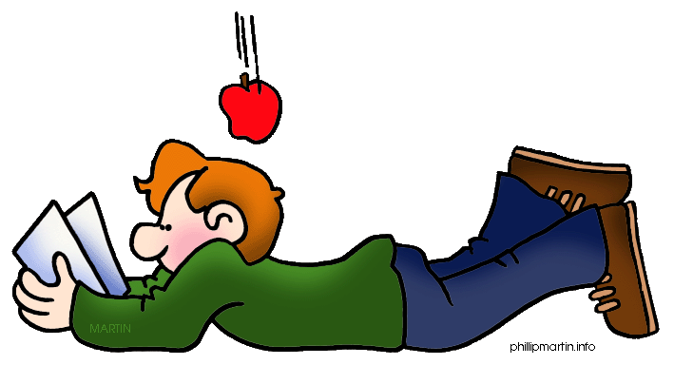
Physics 20
Course Outline
Semester One
Mrs. Jorgensen – Room 101
Course Content
Unit A: Kinematics
This unit investigates changes in the position and velocity of objects and systems in a study of kinematics.

Key Concepts:
• scalar quantities • uniform motion
• vector quantities • uniformly accelerated motion
• two-dimensional motion

Unit B: Dynamics
In this unit, you investigate causes of change in the position and velocity of objects and
systems in a study of dynamics and gravitation. The concept of fields is introduced in the explanation of gravitational effects.

Key Concepts:
• Newton’s laws of motion • inertia
• vector addition • static and kinetic friction
• gravitational force • Newton’s law of universal gravitation
• gravitational field

Unit C: Circular Motion, Work and Energy
In this unit, you will extend your study of kinematics and dynamics to uniform circular
motion and to mechanical energy, work and power.

Key Concepts:
• uniform circular motion • conservation of mechanical energy
• planetary and satellite motion • work-energy theorem
• Kepler’s laws • isolated systems
• mechanical energy • power

Unit D: Oscillatory Motion and Mechanical Waves
In this unit you will investigate simple harmonic motion and mechanical waves.

Key Concepts:
• oscillatory motion • oscillating spring, pendulum
• simple harmonic motion • restoring force
• mechanical resonance • mechanical waves—longitudinal and
• Doppler effect transverse
• universal wave equation • acoustic resonance
• reflection • interference
Course Timeline
Unit A: Sept. 2nd – Oct 22nd (22 days)
Unit B : Oct 23rd - Nov. 5th (22 days)
Unit C : Nov 8th – Dec 8th (20 days)
Unit D: Dec 9th –Jan 19th (20 days)

Review : January 20th and 21st

Course Evaluation
A. Year’s work Exams 70%
Labs 10%
Assignments 10%
Quizzes 10%

B. Final Mark Year’s work 70%
Final Exam 30%

Labs: There will be periodic labs throughout the semester. The weighting on the labs will not be equal, as the marks will be calculated using the raw scores of the labs. If a student has an unexcused absence on the day of a lab a mark of “0” will be given.

Assignments: Periodic assignments will be marked using raw scores as well, which means that some reports and assignments will have heavier weighting than others.

Quizzes: The quizzes will be mostly short answer questions. Examples of the types of questions are those that require you to label diagrams, do matching, show calculations or answer a theory question. The quizzes will typically be no longer than 40 minutes each. Each quiz will be recorded as a raw score and the raw scores will determine their weighting.

Exams: There will be 4 exams in the course. The weighting on all exams will be close to equal, marks will be calculated using raw scores. The slightly longer units (A and B) will result having slightly heavier weightings. All exams will be composed of multiple choice and numerical response.

Final Exam: There will be a cumulative final exam scheduled during exam week. The exam will consist of both multiple choice and numerical response questions and will account for 30% of the final mark.

