Science 24

Teacher: Mrs. Jorgensen Room 101

Science 24 is the second course in the Science 14-24 series.

Successful completion of this course will provide the minimum requirements in science for an Alberta high school diploma.

Science 24 will help you learn to appreciate science in your day to day life, while also helping you to make smarter and better decisions in things related to science. The focus is on the development of personal skills, social understanding, self-confidence, and preparation for the world of work.

Unit 1 – Matter and Chemical Change Chapters 1-4
- Useful Chemistry
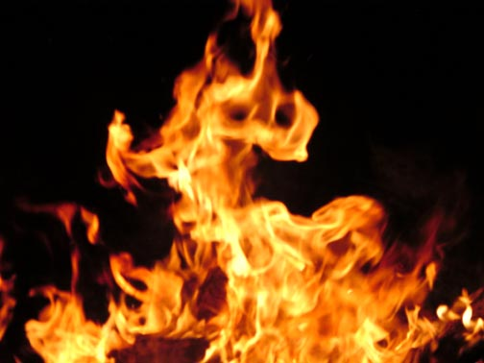
- Common Reactions in Our Lives
- Types of Chemical Reactions
- Reactions and the Environment

Unit 2 – Energy Transformations Chapters 5-8
- Energy Conversions
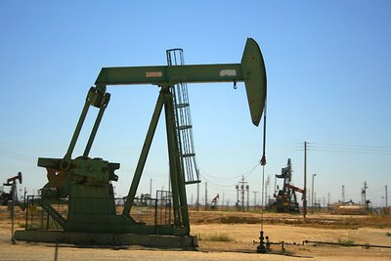
- Electric Energy at Home
- Energy for Life
- Fossil Fuels

Unit 3 – Disease Defense and Human Health Chapters 9-12
- Disease
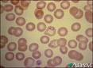
- Society’s Response to Disease
- Protecting Yourself from Disease
- Genetics and Health

Unit 4 – Safety in Transportation Chapters 13-16

- A Need for Safety
- The Nature of Speed
- The Physics of Collisions
- The Technology of Safety

Approximate Timeline

Unit # days Exam Date
Unit A 22 days Wednesday, October 3rd
Unit B 22 days Tuesday, November 6th
Unit C 20 days Monday, December 10th
Unit D 20 days Monday, January 21st
Review @ 2 days January 22nd & January 23rd

Marks

Your report card mark and final marks will be calculated as follows:
Unit exams 25%
Assignments 30%
Labs 5%
Quizzes 20%
Final Exam 20%

Exams: There will be four unit exams in this course. Each exam will consist of multiple choice and written response questions. The weighting of the exams will be equal.

Quizzes: There will be a quiz every Tuesday “Testy Tuesday.” The weighting of each quiz will be determined by their raw scores. Quizzes may include a variety of question types including multiple choices, true/false, fill-in-the blank and short answer.

Assignments: There will be a number of assignments throughout the semester. The weighting on assignments will not be equal, as the marks will be calculated using the raw score. Some assignments will be longer and will therefore be weighted heavier.

Labs: There will be a number of labs throughout the semester. If you have an unexcused absence on the day of a lab, you will receive a “0” for that lab. The weighting on labs will not be equal as marks will be calculated using raw scores.

Final Exam: At the end of the semester there will be a final exam that covers all the material from the semester. This exam will be written during exam week at the school.

Class Materials : pens, pencils, binder, calculator (simple, inexpensive), dividers

