Mrs. Jorgensen – Room 101
Semester One
Science 10 Outline

Unit 1: Energy and Matter in Chemical Change (26 days)

You will learn –
- To describe the basic particles that make up matter
- To use the periodic table to describe how elements combine to form compounds and how to name them
- To identify and classify chemical changes and to write word and balanced chemical equations for chemical reactions

Chapter 1 – Atoms, Elements and Compounds
Chapter 2 – Names, Formulas and Properties
Chapter 3 – Chemical Reactions
Unit 2: Energy Flow in Technological Systems (19 days)

You will learn -
- To analyze and illustrate how technologies based on thermodynamic principles were developed before the laws of thermodynamics were formulated
- To explain and apply concepts used in theoretical and practical measures of energy in mechanical systems
- To apply the principles of energy conservation and thermodynamics to investigate, describe and predict efficiency of energy transformation in technological systems
Chapter 4 – Thermal Energy and Work
Chapter 5 – Energy and Motion
Chapter 6 – Energy Conversions and Efficiency
Unit 3: Cycling of Matter in Living Systems (19 days)

You will learn -
- The relationship between imaging technology and the current understanding of the cell
- The function of organelles and structures in a cell, in terms of life processes
- About plants as an example of a multicellular organism with specialized structures at the cellular, tissue and system levels
Chapter 7 – The Basis of Life
Chapter 8 – Dynamic Cells

Chapter 9 – From Cell to Organism: Focus on Plants
Unit 4: Energy Flow in Global (18 days)

You will learn -
- How the relationships among input solar energy, output terrestrial energy and energy flow within the biosphere affect the lives of humans and other species
- Analyze the relationship among net solar energy, global energy transfer processes – primarily radiation, convection and hydrologic cycle – and climate
- Relate climate to the characteristics of the world’s major biomes, and compare biomes in different regions of the world
- Investigate and interpret the role of environmental factors on global energy transfer and climate change
Chapter 10 – Solar Energy and Climates
Chapter 11 – Climates and Biomes
Chapter 12 – Climate Change and Humans

Course Review (4 days)

Approximate Timeline (please note Exam dates are subject to change)
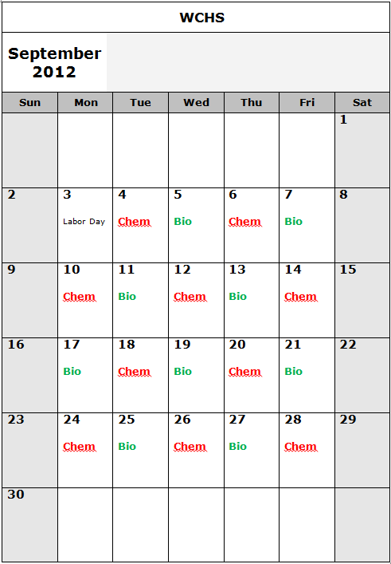
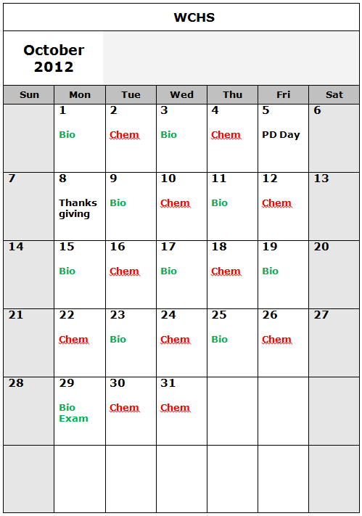

•Please note that these quiz and exam dates are subject to change.

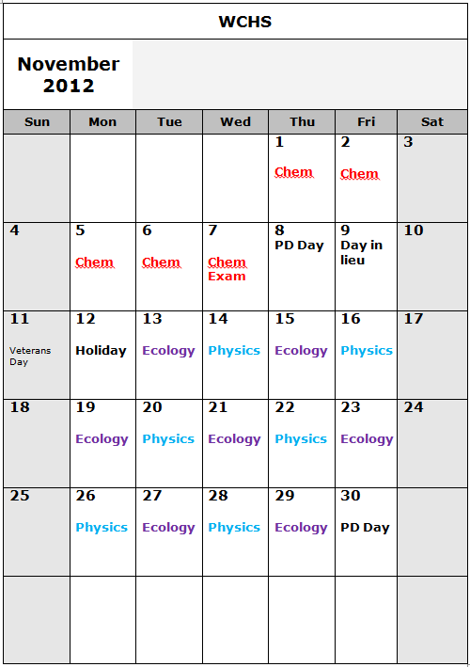
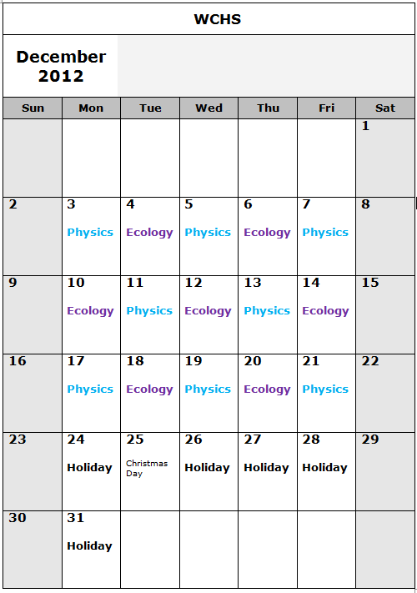

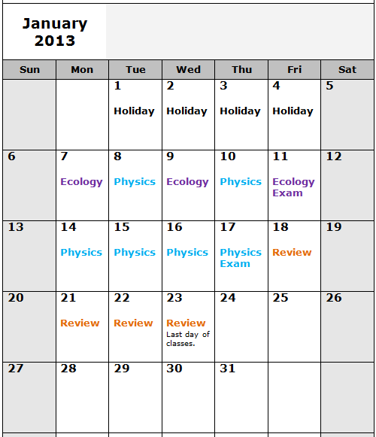
Course Evaluation
1. Assignments 20%
2. Labs 5%
3. Quizzes 20%
4. Unit Exams 30%
5. Final Exam 25%
Report Card marks are cumulative.

Exams – The exams will consist of a combination of multiple choice, numerical response and long answer questions. Each exam will be recorded as a raw score and the raw scores will determine their weighting. All four exams will be weighted very closely.

Quizzes – The quizzes will be mostly short answer questions. Examples of the types of questions are those that require you to label diagrams, do matching, show calculations or answer a theory question. The quizzes will typically be no longer than 40 minutes each. Each quiz mark will be recorded as a raw score and the raw scores will determine their weighting.

Labs – The labs that you conduct will require either partial or full lab write-ups to be submitted for marks. Lab skills may also be assessed.

Assignments - Assignments will be based on course work and the weighting of an assignment will be determined by its length.

Final Exam – The final exam will consist of multiple choice questions, numerical response questions. (Long answer questions may be added according to teacher discretion.) The exam is designed to be 2 hours in length.

Mrs. Jorgensen’s Class Expectations

1. Be Respectful. The classroom is an environment where everyone should feel safe, included and welcome. Please respect yourself, myself, my classroom and your classmates.

2. Be on Time!!
    - Class begins when the bell goes. You are late if you are not in the room when the bell goes. Lates are an interruption to learning of others and show a lack of respect for your classmates and myself.
    - If you are late please wait in the hall until I come get you, this way we limit the interruption your tardiness will cause.

3. “Listen Up” This is your cue that I need your attention quickly.

4. Sign-Out. When given permission to leave the classroom please sign-out on the board and erase you name upon your return.
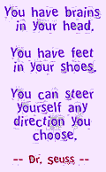
5. Redo Opportunities. All students taking Science courses are eligible to request a redo of any evaluative activity other than the final exam. Please see the handout WCHS Science Department Redo Policy and Request Form for details and procedure. This is a privilege, not a right. You may be denied a redo if you fail to take the course or the redo opportunity seriously.

6. Attend Class. What we do everyday matters!! Excessive unexcused absences will not be tolerated. It is your responsibility to catch up on any missed homework, notes, and handouts. All extra handouts can be found in the trays above the filing cabinet.
  - Please plan around exam dates All students are expected to be present when an exam is scheduled. If a student is absent the day of an exam the following will occur:
    - If the absence is excused the student can write the exam by following the Science Department Exam Make-Up Policy
    - If the absence is not excused by the parent/guardian (office notified of absence the day of the exam) the student will receive a mark of zero.

7. School Supplies.

-

-

-

8. As per school policy there will be no hats, no cell phones and no ipods/mp3s, cameras.

9. Actively Participate. - what you do everyday in this classroom matters!! Success in this
course is dependent on your participation in the course.

Please don’t let little problems become big problems. If you are having trouble with a concept or homework please come and see me. I am looking forward to teaching you this semester and hope to offer you a variety of learning activities that will peak your scientific curiosity and help you have a successful school year.

Mrs. Jorgensen

