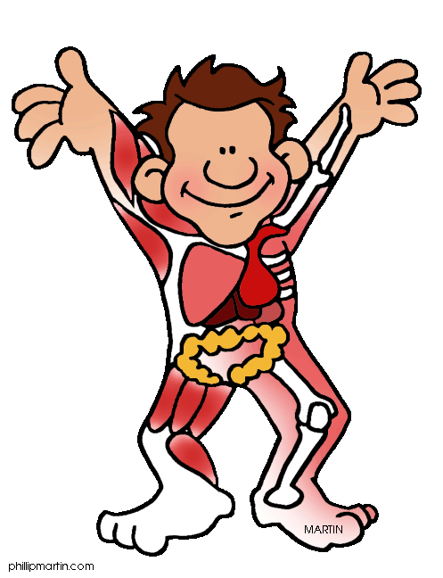
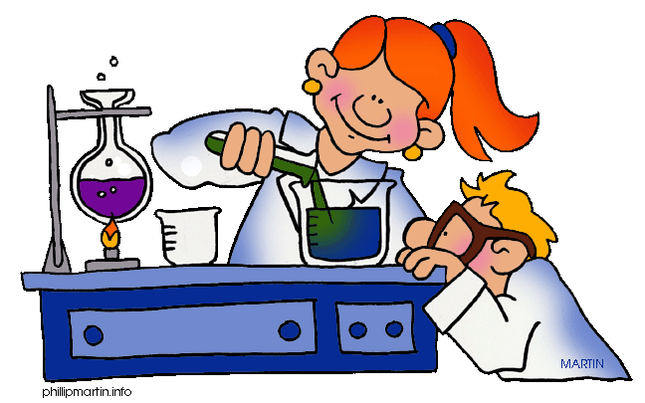
Science 14
Mrs. Jorgensen – Room 101

Textbook:
McGraw-Hill – Science Connect 1

COURSE CONTENT

Unit A Investigating Properties of Matter:
January 31st – March 6th
- Handling, storing, and disposal of chemicals at home and in the laboratory
- WHMIS and consumer products symbols for labeling substances
- Solutions and solubility of household products and relate this to practical applications
- Separate the components of mechanical mixtures and solutions
- Link concentration changes to the concept of dilution, and prepare solutions
- Identify acids and bases through the use of a pH scale and litmus paper
- Use the periodic table of elements and write the chemical formulas for elements and simple compounds
- Investigate corrosion and rusting

Unit B Understanding Energy Transfer Technologies:
March 7th – April 16th
- Cooling and heating systems are based on radiation, conduction, and convention
- Temperature, thermal energy, and heat; and their effect on the particle model of matter
- Explain the technologies that reduce loss of heat from buildings, our bodies, and constructed devices
- Specific heat capacity
- Simple machines as devices that transfer energy
- Energy transfer (work), force and distance
- Non renewable energy sources

Unit C Investigating Matter and Energy in Living Systems:
Apri1 7th – May 15th
- Diets and human nutritional needs
- Structure and function of digestive and circulatory systems, and the relationship between
- Eating disorders and circulatory diseases due to social influences on human dietary
- Structure and functions of the parts of plant and animal cells and the cell theory
- Identify life functions common to living systems, and the organs and systems that carry out these functions
- Photosynthesis and cellular respiration
- The role of technology to monitor life functions

Unit D Investigating Matter and Energy in the Environment:
May 16th – June 17th
- Role of living organisms in the cycling matter
- Food chains, food webs, and the flow of energy
- Recycling of human waste, biodegradable materials
- Impact of technologies on agriculture and the environment
- Ecosystems and their biotic and abiotic components
- Human impact on ecosystems and their population growth.
- Study ecosystems present in Alberta
- Equilibrium in the biosphere

Review June 18th and June 19th

COURSE EVALUATION

Lab Reports 5%
Assignments 30%
Quizzes 20%
Unit Exams 25%
Final Exam 20%

Assignments: There will be assignments throughout the semester. The weighting on the assignments will not be equal, as the marks will be calculated using the raw score of the assignments. Some assignments will be longer, and therefore will be weighted heavier. If you are absent the day an assignment is collected, it is your responsibility to make sure you hand it in when you return.

Lab Reports: Students are responsible for completing all lab work and handing in assigned work. Lab reports will be handed in for a raw score. If a student has an unverified absence on the day of a lab a mark of “0” will be given.

Quizzes: There will be a quiz every Friday. Quizzes will be cumulative. There will be an emphasis on material from the past week, but some questions may cover material covered in previous weeks. Quiz marks will be calculated using raw scores so the weighting will not be equal. Quizzes will be composed of a variety of questions, including multiple choice, true/false, fill-in-the-blank and short answer.

Unit Exams: There will be 4 exams in the course. The weighting on all exams will not be equal, as the marks will be calculated using raw scores. Unit exams will be a combination of multiple choice, numerical response and written response questions. If you miss an exam, you will be expected to write it after school on either Tuesday or Thursday following your return to school.

Final Exam: There will be a cumulative final exam scheduled during exam week. The exam will consist of multiple choice, numerical response and written response questions. The final exam will account for 20% of the final mark.

Required Materials:
- Binder
- Lined paper
- Pens and pencils
- Scientific calculator

Student Expectations:
- It is very important that you are here everyday and on time! We have lots of concepts to cover in this course and in order to be successful you need to be here.
- If you know you are going to be away please let me know ahead of time. The work that you missed when you were away is your responsibility. You must complete this work on your own time and within a reasonable time frame. You can ask a classmate for notes, check the school website, or contact me. Any missed quizzes or exams must be written on your own time and as soon as possible.
- Food and drinks are not allowed in the classroom.
- Homework will be assigned regularly and be checked for learning (formative).
- Classroom and laboratory safety procedures must be followed at all times. If these procedures are not followed, students can lose lab privileges. Any behavior that disrupts the classroom will be dealt with as necessary.
- The classroom and school environment is based around respect, cooperation, and effort from students and teachers.
- It is expected that you are completing your own work, there is zero tolerance for copying and/or cheating.
- Rewrites will be permitted please see the Science Department’s Redo Policy

