Icosahedron Element Project

Purpose: To research and become an expert on one specific element.

Format: The information gathered will be presented in the form of an icosahedron (see attached instructions for the creation of the icosahedron).

Materials: To make you icosahedron, you will need: all the information about your element construction paper or card stock, and any decorations you wish to add (see example).

Necessary Information: On your icosahedron, you will need to include the following information about your element:
1. Your name and period
2. Element Name
3. Family Name
4. Classification (metal, nonmetal, metalloid)
5. Number of Protons
6. Number of Electrons
7. Common isotopes (include number of neutrons and mass number for each)
8. Atomic Mass
9. Atomic Number
10. Melting Point, boiling point, and freezing point (in C or F)
11. Most common phase/natural state (solid, liquid, or gas)
12. Discovery date and other information about discovery
13. Cost ($ per gram/ounce/mL)
14. Characteristics and properties (color, smell, etc)
15. Common uses (found in bananas, milk, used to make cans, etc)
16. Electron dot configuration
17. Group Number and Period Number
18. Where it is most often found (countries, type of geography, etc)
19. Interesting Fact 1
20. Interesting Fact 2
*Each piece of information goes on a different side of the icosahedron

Rubric: You will be graded on the following criteria:
10 points - Neatness, creativity, color, decoration
40 points - Inclusion and accuracy of the necessary information (2 points per side)
50 points Total

Each student will select from a list of elements and must research the element they select. We will have one research day in class to obtain the information-Monday, October 26th . You will lose points if you do not have all of the above information. You can type your information on the template included in this packet or neatly write in the information. The element icosahedron is due Friday, October 30 at the end of class. You will have the class period to assemble it, have your information printed out on the templates.
Recommended Websites

Project information, template and assembly information can be found at:
http://teacherweb.com/FL/LakelandHighSchool/MsPierceHonorsChemistryII/

http://www.webelements.com/

http://periodictable.com/

http://www.chemicool.com/

http://www.chemicalelements.com/

http://www.lenntech.com/periodic-chart.htm

http://education.jlab.org/itselemental/index.html

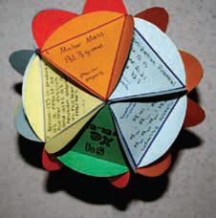
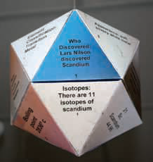

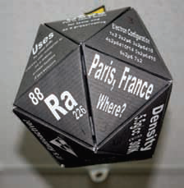
Icosahedron
type text here
Pattern
type text here
Patterns for Faces
type text here
of Icosahedron
type text here
Patterns for Faces
type text here

of Icosahedron
type text here
Patterns for Faces
type text here
of Icosahedron
type text here
Patterns for Faces
type text here
of Icosahedron
type text here
Patterns for Faces
type text here
of Icosahedron
type text here
Patterns for Faces
type text here
of Icosahedron
type text here
Patterns for Faces
type text here
of Icosahedron
type text here
Patterns for Faces
type text here
of Icosahedron
type text here

Patterns for Faces
type text here
of Icosahedron
type text here
Assembling the Icosahedron
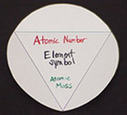
- Prepare your faces -- 10 will have the base of the triangle at the bottom and 10 will have the base at the top. The face above has the base at the TOP.
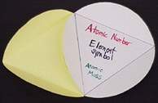
- Fold on the solid lines so that the flaps face away from or towards the two faces you will be attaching. Attach two faces together with either the flaps on the inside or outside of your icosahedron. The two attached above have the flaps OUT. Glue from a glue stick was used to make the attachments shown here.
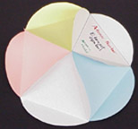
- To make the top or the bottom, attach 5 faces together as shown above with the flaps IN, OUT, or any combination. The top for the icosahedron should have the base of the triangles at the bottom of your faces and the bottom for the icosahedron should have the base of the triangle at the top. The picture above is the bottom of an icosahedron.
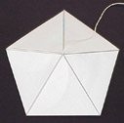
- When assembling the top, be sure to include a hanger -- sting , wire, ribbon. You should secure the hanger in place on the inside of your icosahedron. The top of an icosahedron, with all the flaps IN, is shown above.
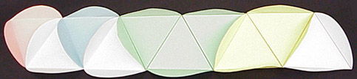
- Assemble 10 faces as shown above. The position of the base of the triangles alternate TOP to BOTTOM as you connect them. The one shown above has some flaps IN and some OUT.
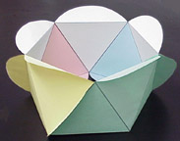
- Attach the two ends of the strip to make a circle as shown above. This is the middle portion of the icosahedron.
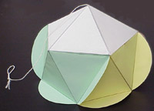
- Attach the top of the icosahedron to the middle portion as shown above.
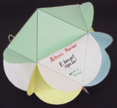
- Attach the bottom of the icosahedron to the middle portion. The view above shows the bottom portion and middle portion (green) of the icosahedron.

