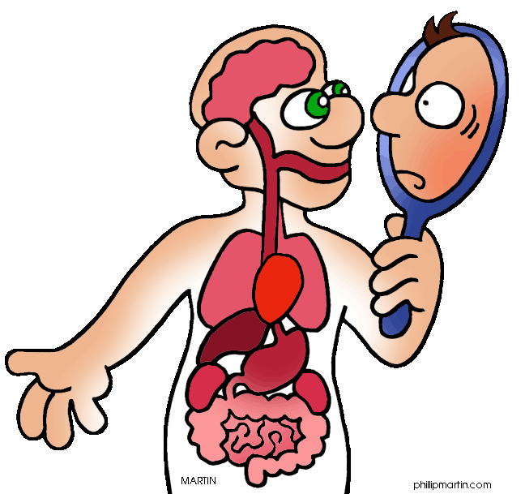

Biology 20 Course Outline

Mrs. Jorgensen - Room 101

Course Content
Unit A: Energy and Matter Exchange in the Biosphere
Textbook Chapter 5 Exam: Sept 24th
Questions we will explore: How are carbon, oxygen, nitrogen and phosphorus cycled in the biosphere? How is the flow of energy balanced in the biosphere? How have human activities and technological advances affected the balance of energy and matter in the biosphere?
Key Concepts:
-biosphere -food chains, food webs and ecological pyramids
-equilibrium - carbon, nitrogen, oxygen and phosphorus cycles
-trophic levels - water properties

Unit B: Ecosystems and Population Change
Textbook Chapter 5 Exam: Oct 25th
Questions we will explore: What are the major biotic and abiotic characteristics that distinguish aquatic and terrestrial ecosystems? What data would one need to collect in a field study to illustrate the major abiotic characteristics and diversity of organisms? What mechanisms are involved in the change of populations overtime? In what ways do humans apply their knowledge of ecosystems to assess and limit the impact of human activities?
Key Concepts:
-ecosystem -adaptation and variation -niche
-biotic/abiotic -population -species
-natural selection -evidence of evolution -limiting factors
-binomial nomenclature

Unit C: Photosynthesis and Cellular Respiration
Textbook Chapter 5 Exam: Nov 13th
Questions we will explore: How does light energy from the environment enter living systems? How is the energy from light converted to chemical potential energy in organic matter? How is the energy in organic matter released for use by living systems? How do humans in their application of technologies impact photosynthesis and cellular respiration?
Key Concepts:
-absorption of light by pigments - Krebs Cycle
-light independent and light-dependent reactions -electron transport systems
-glycolysis -aerobic and anaerobic respiration

Unit D: Human Systems
Part 1: Chapters 6,7,10 Exam: Dec 11th
Part 2: Chapters 8&9 Exam: Jan 17th
Questions we will explore: How do specialized structures function in the overall biochemical balance of the living system? What conditions result if these structures do not function normally? How does knowledge of living systems and medical technology support the prevention and treatment of disorders?

Key Concepts:
-structure and function of major -digestive enzymes -gas exchange
systems: respiratory, digestive, -renal function -blood
excretory, circulatory and motor -muscle contraction -immune response
-chemical nature of carbohydrates, -chemical & physical digestion
proteins, lipids

Course Evaluation
Assignments 8% Lab Assignments 7%
Field Study 5% Quizzes 20%
Unit Exams 30% Final Exam 30%

Labs: Labs will be performed and students are responsible for completing the appropriate lab work and assignments, which will be handed in for a raw score. If a student has an unexcused absence on the day of a lab a mark of “0” will be given.

Assignments: There will be assignments throughout the semester. The weighting on the assignments will not be equal, as the marks will be calculated using the raw score of the assignments. Some assignments will be longer, and therefore will be weighted heavier.

Quizzes: There will be a quiz every Friday. These quizzes will emphasize material from the past week, but may also include questions from previous weeks and/or units, therefore these quizzes are cumulative. Quiz marks will be calculated using raw scores so the weighting will not be equal. Quizzes will be composed of a variety of types of questions, including multiple choice, true/false, fill in the blank, and short answer. If a student has an excused absence on a Friday – the expectation is that they write Monday at lunch.

Exams: There will be 5 exams in the course. The weighting on all exams will not be equal, as the marks will be calculated using raw scores. This will result in longer units having slightly heavier weightings. Exams may be composed of multiple choice, numerical response and written response.


Final Exam: There will be a cumulative final exam scheduled during exam week. The exam will consist of both multiple choice and numerical response questions and will account for 30% of the final mark.

