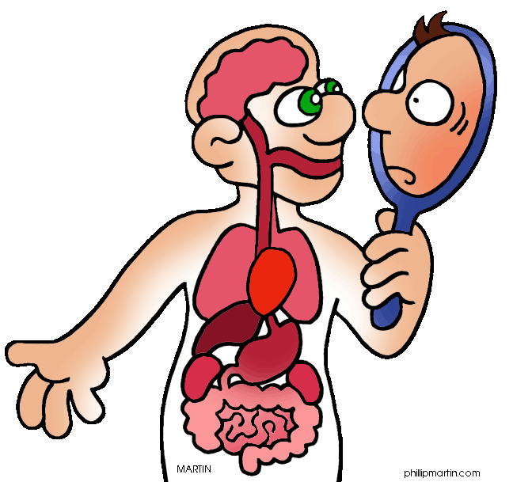

Biology 20 Course Outline
Mrs. Jorgensen - Room 120

Course Content
Unit D: Human Systems - Part 1: Chapters 6,7 & 10 Exam: March 1st, 2017
- Part 2: Chapters 8 & 9 Exam: April 5th, 2017

Questions we will explore: How do specialized structures function in the overall biochemical balance of the living system? What conditions result if these structures do not function normally? How does knowledge of living systems and medical technology support the prevention and treatment of disorders?
Key Concepts:
-structure and function of major -digestive enzymes -gas exchange
systems: respiratory, digestive, -renal function -blood
excretory, circulatory and motor -muscle contraction -immune response
-chemical nature of carbohydrates, -chemical & physical digestion -proteins, lipids

Unit A: Energy and Matter Exchange in the Biosphere - Chapters 1 and 2
Exam: April 25th, 2017
Questions we will explore: How are carbon, oxygen, nitrogen and phosphorus cycled in the biosphere? How is the flow of energy balanced in the biosphere? How have human activities and technological advances affected the balance of energy and matter in the biosphere?
Key Concepts:
-biosphere -food chains, food webs and ecological pyramids
-equilibrium - carbon, nitrogen, oxygen and phosphorus cycles
-trophic levels - water properties

Unit C: Photosynthesis and Cellular Respiration - Chapter 5
Exam: May 10th, 2017

Questions we will explore: How does light energy from the environment enter living systems? How is the energy from light converted to chemical potential energy in organic matter? How is the energy in organic matter released for use by living systems? How do humans in their application of technologies impact photosynthesis and cellular respiration?
Key Concepts:
-absorption of light by pigments - Krebs Cycle
-light independent and light-dependent reactions -electron transport systems
-glycolysis -aerobic and anaerobic respiration

Unit B: Ecosystems and Population Change - Chapters 3 & 4 Exam: June 14th, 2017
Ecosystem – Field Study By the Lake Field trip – Tuesday, May 30th

Questions we will explore: What are the major biotic and abiotic characteristics that distinguish aquatic and terrestrial ecosystems? What data would one need to collect in a field study to illustrate the major abiotic characteristics and diversity of organisms? What mechanisms are involved in the change of populations overtime? In what ways do humans apply their knowledge of ecosystems to assess and limit the impact of human activities?

Key Concepts:
-ecosystem -adaptation and variation -niche
-biotic/abiotic -population -species
-natural selection -evidence of evolution -limiting factors
-binomial nomenclature

Course Evaluation
Labs: Labs will be performed and students are responsible for completing the appropriate lab work and assignments, which will be handed in for a raw score. If a student has an unexcused absence on the day of a lab a mark of “0” will be given.
Evaluative Weightings
1. Labs/ Assignments 10%
2. Homework 5%
3. Quizzes 15%
4. Unit Exams 35%
5. Ecological Field Study 5%
6. Final Exam 30%
Report card marks are cumulative

Assignments: There will be assignments throughout the semester. The weighting on the assignments will not be equal, as the marks will be calculated using the raw score of the assignments. Some assignments will be longer, and therefore will be weighted heavier.

Quizzes: There will be quizzes throughout the semester. Most quizzes will be weekly quizzes (Fridays), others will be “pop-like” quizzes with emphasis on vocabulary and/or homework. Quizzes will be composed of a variety of types of questions, including multiple choice, true/false, fill in the blank, and short answer.

Exams: There will be 5 exams in the course. The weighting on all exams will not be equal, as the marks will be calculated using raw scores. This will result in longer units having slightly heavier weightings. Exams may be composed of multiple choice, numerical response and written response.

Final Exam: There will be a cumulative final exam scheduled during exam week. The exam will consist of both multiple choice, numerical response and short answer questions and will account for 30% of the final mark.
Mrs. Jorgensen’s Expectations
1. Be Respectful. The classroom is an environment where everyone should feel safe, included and welcome. Please respect yourself, myself, my classroom and your classmates.

2. Actively Participate. - What you do everyday in this classroom matters!! Success in this course is dependent on your participation in the course. ASK QUESTIONS!!!

Excessive unexcused absences will not be tolerated. It is your responsibility to catch up on any missed homework, notes, and handouts. All extra handouts can be found in a folder on the side board.
  - Please plan around exam dates. All students are expected to be present when an exam is scheduled. If a student is absent the day of an exam the following will occur:
    - If the absence is excused the student can write the exam by following the Science Department Exam Make-Up Policy
    - If the absence is not excused by the parent/guardian (office notified of absence the day of the exam) the student will receive a mark of zero.



